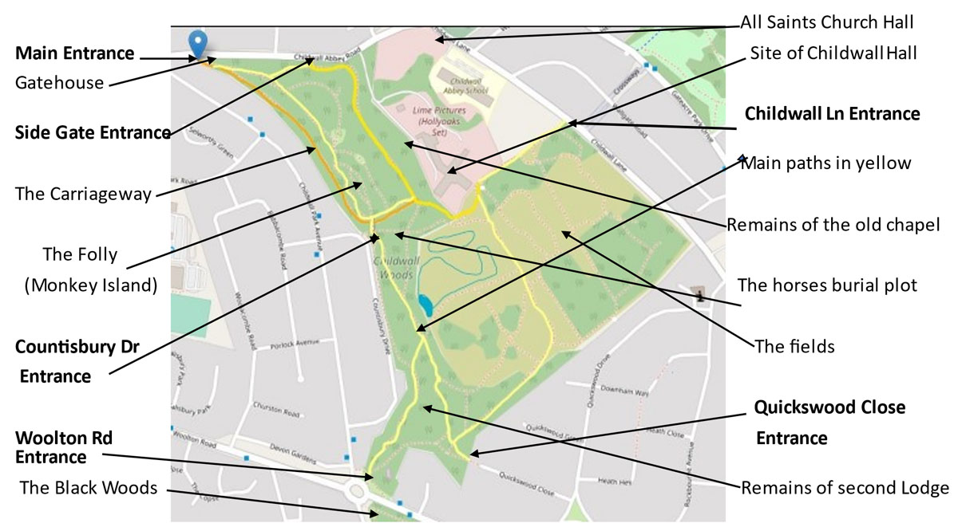

**The Hidden History of Childwall Woods and Fields**