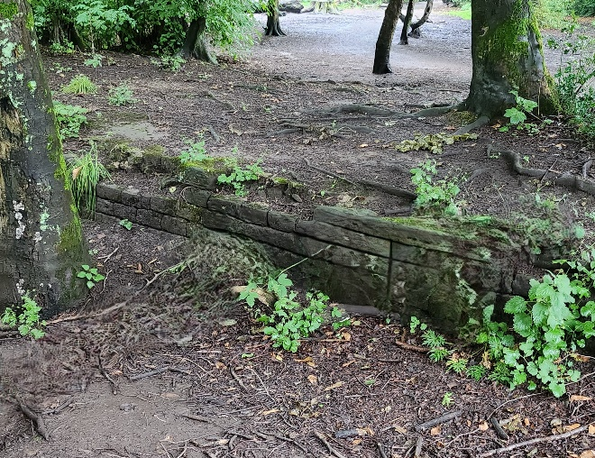

**The Hidden History Hunt**

**How many of these hidden relics can you find?**

**The Carriageway**

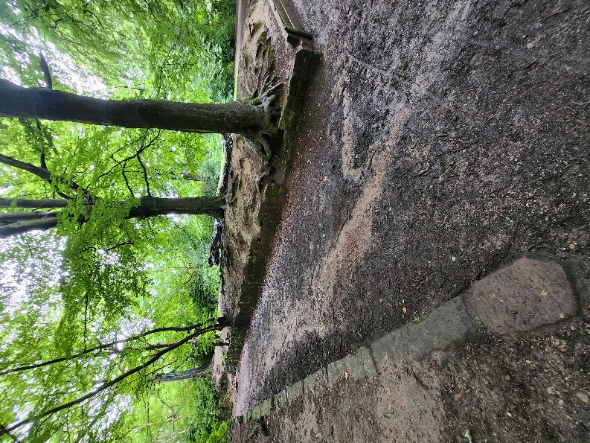

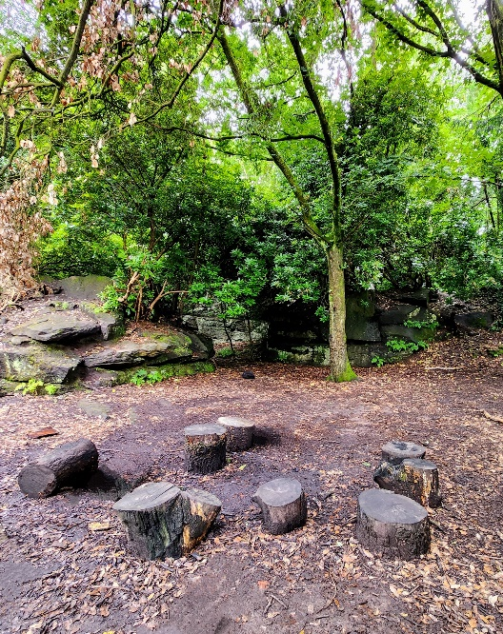 **The ha ha**

**The Folly**

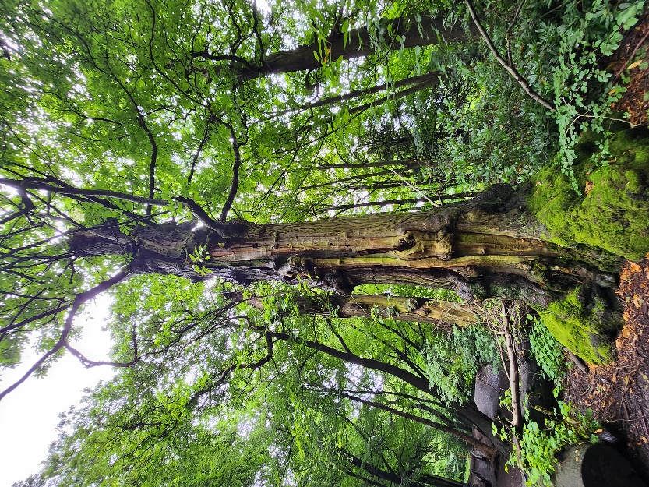

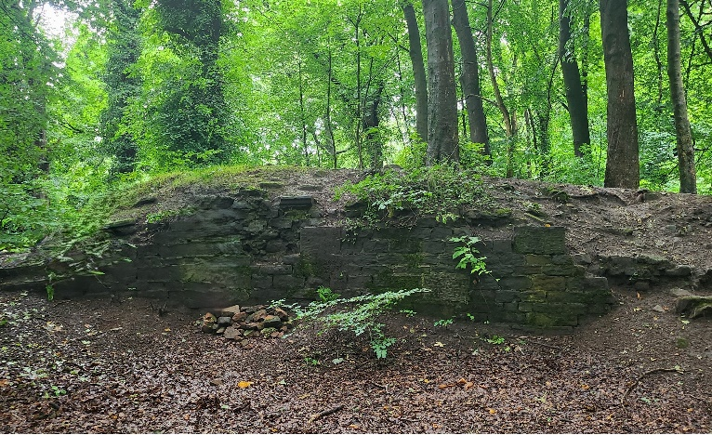

**The oldest tree** **The horses hill**